
THE UNIVERSITY OF BRITISH COLUMBIA OKANAGAN CAMPUS
FACULTY OF APPLIED SCIENCE, SCHOOL OF ENGINEERING

CMPE 246 - Computer Engineering Design Studio
Mid-Term Project Proposal
Smart Desk Assistant: Intelligent Focus Tracking & Adaptive Study Support System

LAB Section - Group: L2A - G5
Due Date: February 27 @ 11:00 PM

Team Members:
Casey Hu, 81776080
Haowei Wen, 36820207
Lea Kallio, 29718988
Minyan Fu, 80972177

Introduction
This proposal outlines the design and development plan for our Smart Desk Assistant, an intelligent workspace companion intended to support productive study habits. The system’s primary purpose is to help users maintain focus by setting timed study sessions and breaks, monitoring attention levels and posture, and providing meaningful feedback based on real-time environmental and behavioural data. When the assistant detects loss of focus, it can deliver corrective feedback ranging from gentle notifications to a moderate water-spray “punishment” mechanism as a humorous yet motivational approach to help the user stay on track.
While in focus mode, the Smart Desk Assistant uses computer vision and machine learning to analyze a live camera feed and detect signs of distraction, such as phone usage, prolonged gaze away from the screen, or poor posture. It also monitors the computer application being used by the user to determine whether the active applications are study-related. Moreover, the assistant incorporates temperature, noise, and light sensors to measure the study environment and include these metrics in a detailed post-session report.
Additional user-centric features include customizable ambient lighting and optional background music through the system’s LED and speaker modules. The ambient light can automatically adjust based on sensor readings, and facial recognition may be used to load personalized user profiles such as preferred lighting levels, study session lengths, and music settings based on the detected user.

The remainder of this proposal presents our team’s work distribution, project timeline, required hardware and software resources, chosen design patterns, object-oriented architecture, and a reflection on our design process to date.

1. Team Composition & Task Assignment Arrangements (1%)

Team Member | Primary Responsibilities | Secondary Responsibilities
Casey | Hardware Integration, ML, System Architecture, Data Processing | Debugging, Safety Mechanisms
Haowei | UI Design, Prototype Producing, Environmental System Design | Video Editing
Lea | ML, System Architecture, User-Profiles/Facial Recognition, Data Logging | Process Documentation, Presentation Lead
Minyuan | Supply gathering, Circuit building, Hardware Assembling | Video Filming

Team Structure Summary:
Roles were first divided so that every member gets the chance to work on both hardware and software. We also shifted the workload a bit based on every team member’s capabilities and past experiences.

2. Project Plan & Timeline (1%)
Group Meeting on Mondays, 4:00-6:00 PM
Lab Meeting on Wednesdays, 3:30-5:30 PM
Week 1 (2/23 - 3/1): Ideation and Proposal
- Brainstorming and determine feasibility
- Complete project proposal writing
- Compose list of required hardwares & softwares
- Rough early system sketch and task division
Week 2 (3/2 - 3/9): Research, Architecture and Design
- Research and analyze hardware and software requirements
- Identify required supplies and place orders
- Establish GitHub Repository
- Draft system architecture and UML diagram
Week 3 (3/9 - 3/15): Essential Core Implementation
- Set up Raspberry Pi development environment
- Set up camera for basic facial detection and servo for water gun mechanism testing
- Initial environment sensor reading (light, temperature, microphone)
- Program application monitoring system
Week 4 (3/16 - 3/22): Programming Design Integration and Refinement
- Basic UI design and implementation
- Basic distraction and punishment logic programming and implementation
- Basic integration of hardware and software
- Implement and integrate Machine Learning
- Continue/complete programming of sensors, UI, and focus algorithm
Week 5 (3/23 - 3/29): Prototype Creation, Testing and Refinement
- Build early functional prototype
- Test distraction detection, posture detection reliability, multi-user face recognition & profile switching, water gun function, “Safety Mode”
- Stress test with long and complicated study sessions
- Refine hardware or software based on testing results
Week 6 (3/30 - 4/5): Final Debugging & Testing
- Final testing of code and software
- Building 3D printed stand if possible
- Finishing touches on prototype
- Record demo video clips, photos and screenshots
Week 7 (4/6 - 4/9): Video & Presentation Creation
- Produce presentation video
- Prepare for the final presentation

3. Resources: Software, Hardware & Online Materials (2%)
Hardware Resources:
Category | Name
Main Controller | Raspberry Pi 5
Vision Acquisition Module | Raspberry Pi Camera Module / USB Webcam
Actuator Module | Servo Motor (SG90 / MG996R)
 | Mini Water-Pump / Mister
Audio Interaction Module | Microphone module
 | Speaker
Environmental Sensing Module | Light Sensor (Photoresistor / TSL2591)
 | Temperature Sensor (DHT22 / DS18B20)
Environmental Adjustment Module | LED Strip for Adaptive Lighting
Circuit Assembly Accessories | Breadboard
 | Jumper Wires
 | Resistors
Structural Mounting Accessories | 3D Printed / Cardboard Mounting Frame

Software Resources:
Category | Name
Core Operating System | Raspberry Pi OS
Core Programming Language | Python 3
Computer Vision Module | OpenCV (computer vision pipeline)
AI & Machine Learning Module | TensorFlow (classification models)
Web Development & UI Module | Flask(web-based configuration UI + reporting dashboard)
Hardware Control Library | pigpio / RPi.GPIO (for motor & sensor control)
Collaboration & Version Control Tool | GitHub (for repositories etc.)

Online Resources:
Raspberry Pi Documentations, Tensor Flow Documentations/Tutorials, Python Documentations/Tutorials, OpenCV Documentations/Tutorials, Github Documentations/Tutorials

4. Design Patterns for Project Ideation & Prototype Development (2%)
Our team referenced and partially adopted the Embedded System Design and Development Lifecycle Model and the V-model of Design Flows. Which provides a structured framework for planning, prototyping, testing, and refining our Smart Desk Assistant.

4.1 Ideation and Planning Phase Pattern
Our brainstorming resulted in multiple ideas, and then we quickly identified our targeted user group, the hardware and software requirements as well as our human resources and time limit. Based on these factors we measured the feasibility of all plans and ruled out inappropriate ones, which led us to this Smart Desk Assistant that would be modular, scalable, and feasible with the CMPE 246 timeline and requirements.

4.2 Requirements Analysis
We then began by identifying system needs that can provide a stable reference for all future design decisions: multi-user recognition, distraction detection, posture tracking, environmental monitoring, water-gun feedback mechanism, safety and ethical constraints.

4.3 System Architecture and Modular Subsystem Design Pattern
To manage project complexity, we decomposed the system into independent modules such as: Vision subsystem (face detection, posture detection, phone detection), Environment subsystem (light, temperature, noise), Actuation subsystem (servo and pump control), User interface subsystem (Flask-based settings and reports), Data logging subsystem. This ensures team members can work in parallel, reduces coupling between components, and simplifies debugging.

4.4. Layered Architecture Pattern & Iterative Prototyping Pattern
We are structuring the project into clear layers: Input Layer, Logic Layer, Output Layer, UI Layer. We will follow a cyclic process of build → test → refine, which aligns with the weekly development structure in Labs 5–9. This pattern allows us to gradually integrate major subsystems including camera detection, environment sensors, user profiles, and water gun mechanism while continuously testing functionality and fixing issues early.
4.5 Event Driven Pattern and Strategy Pattern for Feedback Modes
The system detects key events such as “user distracted,” “phone detected,” “low light,” or “poor posture.” These events trigger downstream actions like logging, UI updates, or activating the water gun in a decoupled manner. We also plan to implement a strategy pattern for feedback modes that allows the users to switch “punishment methods” without changing the core attention-detection logic.

4.6 Verification, Validation and Refining
As subsystems are developed, each will be tested against the requirements defined earlier, including posture detection validation, actuation safety validation, multi-user profile accuracy, UI usability testing etc. The full system will be evaluated in simulated study sessions to ensure all sensors, ML modules, and actuators operate reliably and safely.

5. Object-Oriented Design & Visual Examples (2%)

5.1 Key Classes
Input/Sensing layer
- CameraSystem: capture_frame(), stream()...
- FaceRecognizer: identify_user(frame), load_profiles()...
- AttentionDetector: detect_posture(frame), detect_phone(frame), detect_inattention(idle_time, face_angle)...
- EnvironmentMonitor: read_light(), read_temp(), read_noise()...

Core Logic Layer
- UserProfileManagement: load_profile(user), save_preferences()...
- SessionManager: start_session(), end_session(), update_state()...
- PunishmentManager: choose_strategy(), trigger_action(event)...
- DataLogger: log_event(), save_daily_report()...

Output/Actuation Layer
- ServoController
- PumpController
- LEDController

UI Layer
- SettingsUI: adjust_sensitivity(), toggle_safe_mode(), change_user_profile()
- ReportUI: visualizes charts, daily summaries

Text-based Explanation:
StudySupervisorController(Main):The StudySupervisorController aggregates and coordinates all functional modules to ensure organized and centralized system control.
CameraModule: This class handles camera initialization and frame capturing.
DetectionModule: This class processes image frames
WaterGunModule: This class manages the feedback system that gives users an alert when they are not focusing.
DataModule: This class records system events, including study duration, break duration, alert counts, and absence periods.

5.2 System Architecture Summary (Textual Visual Example)
Adjust the study mode (Light,music…)
Identify the User
Set the study time
Initialize focus mode
Water gun and buzzer
SAFE
Determine your App
Detect Eyes
Detect holding phone
Determine
Not Study
Study
Detect environment
Record Data
Change Light

Figure 1: Flow Chart of the processing

5.3 Overall UI Deign
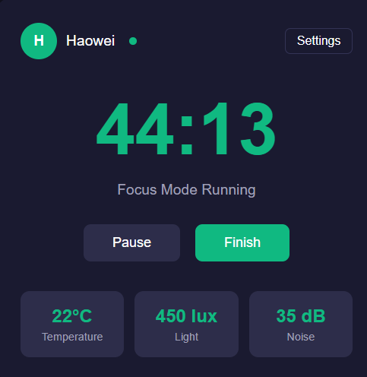
Figure 2: Main UI Interface - Active Focus Session State

This user interface is custom-designed for our smart desk system, integrating core functions including focus session control, real-time environmental sensing data visualization, user identification, and distraction state feedback. We designed it following a distraction-free principle to minimize interference with the user’s study state, and is compatible with both web-based access and the Raspberry Pi embedded display.
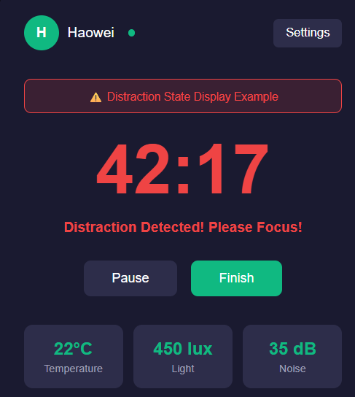
Figure 2.1: Main UI Interface - Distraction Detected State

The figure below shows the setting page of the Smart Desk System, the users could personalize the system’s behavior to match their study habits and environmental preferences. It is divided into three core configuration sections:

1.Time & Mode
- Focus Duration: A slider control that lets users set the length of their focus sessions
- Break Duration: A slider control to configure the length of rest periods.
- Safe Mode: A toggle switch that disables the physical water spray punishment mechanism, while still logging distraction events for user review.
2. Punishiment & Alert
- Distraction Sensitivity: A dropdown menu (Low/Medium/High) that adjusts how strictly the system detects user inattention.
- Water Spray Intensity: A slider that controls the strength of the water spray punishment, which is only active when Safe Mode is disabled.
3. Environment Preference
- Target Light Level: A slider to set the user’s preferred ambient light intensity for studying.
- Auto Light Adjust: A toggle that, when enabled, makes the system automatically adjust the desk’s LED lighting to match the target light level, based on readings from the ambient light sensor.
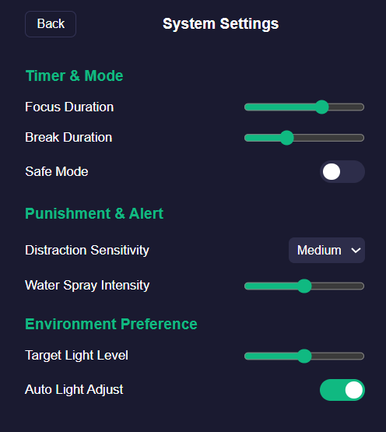
Figure 2.3: System Setting Page
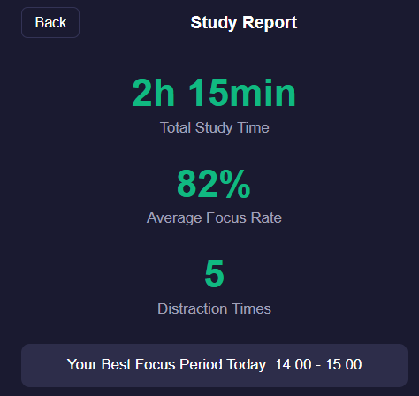
Figure 2.4: Report Page
When the set study time is over, the user will see this Study Report interface, which provides a concise, data-driven summary of the user’s study session performance.
Key metrics displayed include:

- Total Study Time: Representing the total duration of active focus and break sessions logged during the day.

- Average Focus Rate: Calculated as the percentage of time the user was detected to be in a focused state relative to the total study time.

- Distraction Times: Indicating the number of times the system detected user inattention and triggered feedback (either a buzzer alert or water spray, depending on settings).

- Best Focus Period: Highlighting the one-hour window where the user maintained the highest focus rate, helping identify optimal study times for future sessions.

6. Personal Reflection on the Process & Project Design (2%)
At the beginning of this project, our team approached ideation by first brainstorming a wide range of possible concepts individually and then bringing them together for group discussion. From there, we began narrowing down the possibilities by filtering out ideas that were either too simple or too software based, since we wanted to build a project with meaningful hardware and software integration. We also agreed that the final project should be ambitious enough to challenge us, but still realistic given the timeframe and available resources. And then two ideas emerged as strong candidates.
The first idea was a cat monitoring system meant to detect if a cat jumps onto the top of a kitchen counter and then respond by doing something such as using a laser pointer to draw the cat away or to aim and fire a water gun at the cat. We discussed that it could potentially even be extended further to be a full caretaker style program that would be capable of determining the cat’s condition such as if it’s happy, hungry or bored, and perhaps interact with it automatically.
The second idea was a smart desk assistant designed to support studying. This involves computer vision based facial recognition with different user profiles, posture and attention level detection, computer using activity monitoring, environmental sensing (temperature, noise level, ambient light level etc.), and post-study session reports generating. As Engineering students, we collectively thought this idea is more personally relevant and more aligned with our daily needs. Ultimately we combined the more playful element (water spray element) of the first cat monitoring system idea with the functionality of the second smart study assistant idea to create something both practical and unique: a focus tracking smart study assistant capable of giving either serious or humorous reinforcements when the user is distracted.
After establishing this initial core idea, we conducted a second brainstorming session in order to explore additional features and their feasibility. We categorized these features into core requirements and stretch goals, which helped us stay grounded while maintaining creativity at the same time. This also led us into the choosing of design patterns where we think more clearly about how the project should be architectured and developed in stages.

The project design process has gone well thus far in terms of working as a team. We have agreed on the same general goals and we keep ourselves on track during group meetings. The diversity of ideas in the group has contributed greatly to our ideation process, allowing us to consider multiple ideas and identify what is the best. We also have a diversity of experiences since our group consists of both Electrical and Computer Engineering students with different projects done in the past, so when discussing how to go about achieving the features of our design there are varied suggestions about what approach to take.

Our goals for the final prototype of the smart desk assistant are admittedly relatively ambitious for the time and monetary constraints. However, we decided we wanted to challenge ourselves to create something interesting and unique of which we can be proud of since its blend of practicality, creativity, and humor reflects our shared interests and strengths. It is our belief that our genuine passion for the ideas we’ve come up with will push us to create a high-quality deliverable that reflects our vision.

Appendix
Brain Storming
- Study assistant that tracks when you’re paying attention and shoots you with a water gun if you’re not
- May use eye tracking or training based on one of us to identify when we’re paying attention
- Identifies when you’re holding a phone
- Identify your posture and remind you if you are at a bad posture
- Identifies pupil size
- Set the study time and break time at first
- Take a screenshot of your desktop and analyze it with machine learning to automatically judge whether you are studying or we can also write a program to pull up the task manager to see what kind of software you are using. Also if the user doesn’t conduct any operations for a couple of minutes it will remind the user of the zoning out.
- Provide an environmental light when it is dark
- Use microphone to measure the noise level/temperature sensor to record the temperature
- Multiple user profiles, uses facial recognition to set things to the user’s presets such as light, background music, preferred study times
- Report each day telling sound level, light level, number of times distracted/studied, or even the subject of studying, favorite music etc.
- Safe mode where you don’t get punished or notified if you’re not paying attention, but the numbers of minutes spent distracted are in daily report
- UI for settings

Reference
Shvets, A. (2021). Dive into design patterns. Refactoring.Guru.

